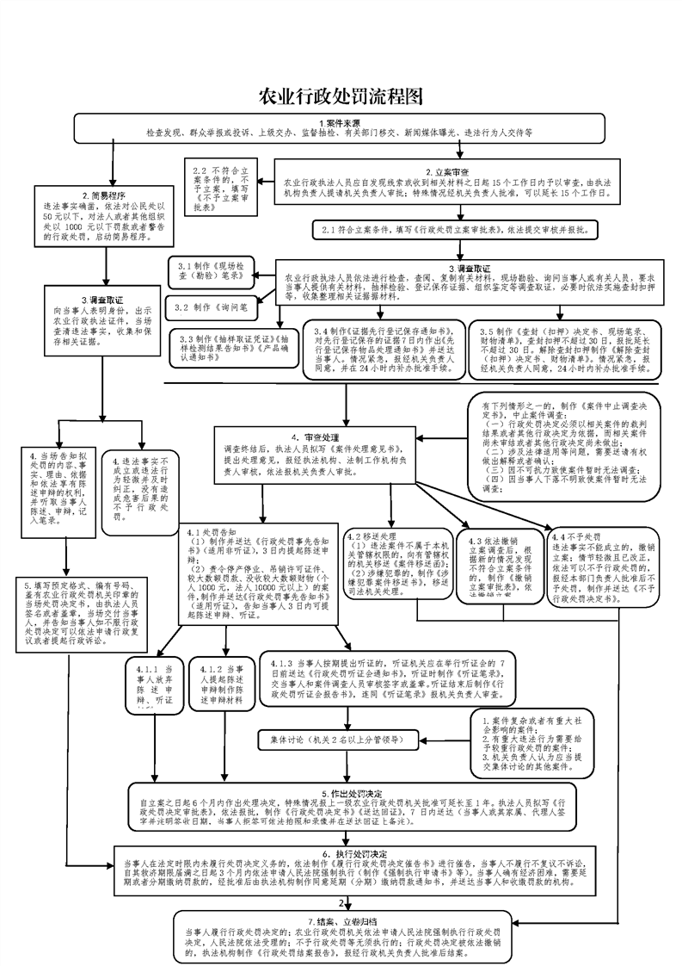

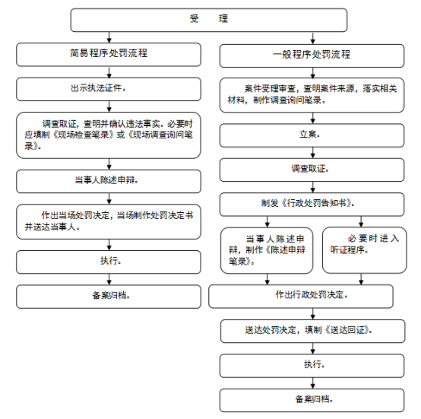

### http://view-cache.book118.com/view3/M05/24/00/wKh2BV1lKj6AMEt3AACY7hLKOAY086.png

### http://www.huarong.gov.cn/uploadfiles/202110/20211015101258742001.png